**Achieve**

**Believe**

**CLASS 5/6 half term newsletter**

**Share**

**Care**

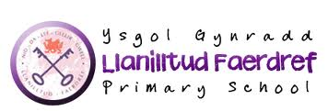

**Governor’s Newsletter FEB 2013**

**Governor’s Newsletter FEB 2013**

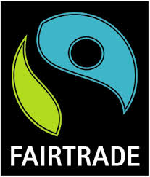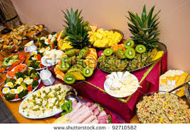

**Class Routines to be aware of:**

Big Maths/Spelling Tests – Friday

Homework Due in – Monday

PE - Friday

Reading Book – to be brought in every day

**This term our topic is…**

**Global Gourmet**

**This project has a food design and technology focus and teaches children about different food types from around the World, fair trade and the importance of eating a healthy diet for well being. At the heart of this project children will learn how to write formal and informal letters and develop additional skills in writing to advertise and inform.**

**In the Innovate Stage children apply their skills and understanding by opening an International Café for the day.**

**In this project the children will learn:**

**• Where food originates from, and how food has a ‘carbon footprint’ which affects the cost;**

**• About the cultural traditions relating to food; how food production is important to particular countries;**

**• How diet affects our health and well being;**

**• To make accurate measurements and calculate costs of food and ingredients;**

**• To develop basic food technology skills and follow recipes;**

**• To collaborate as a team, deciding on strengths, weaknesses and interests of team members;**

**Homework/How parents can help:**

Homework will usually be given to introduce a new topic and to consolidate learning.

Parents can help their children throughout this topic by:

- discussing where foods are

produced by looking at food

packaging.

- encouraging and helping children

to cook, following recipes and

measuring ingredients.

Continue practising spelling words, Big Maths methods and 6 times tables.

thechoirch

**Dates for the Diary**

Happy’s Circus – Friday 11th September

Jeans for Genes Day –Friday 18th September

Trip to Green Meadow Farm – Friday 25th September

Book Fayre – week beginning 5th October

INSET Day – Friday 23rd October

